Teress Tinga – CPRG303B

Lab Assignment 1: Spinning UP React Native App

**Guidelines**

Come up with a Word or Markdown document that includes the following:

1. System requirements:

Processor: 11th Gen Intel® Core™ i7

RAM: 64.0 GB (63.7 usable)

Windows Edition: Windows 11 Pro

1. Installation instructions: Include step-by-step instructions for installing the necessary tools and dependencies required for the framework, such as Node.js, and the React Native CLI.
   1. Before downloading & installing Android development environment, make sure to download & install first Node.js. Make sure to download the LTS version.

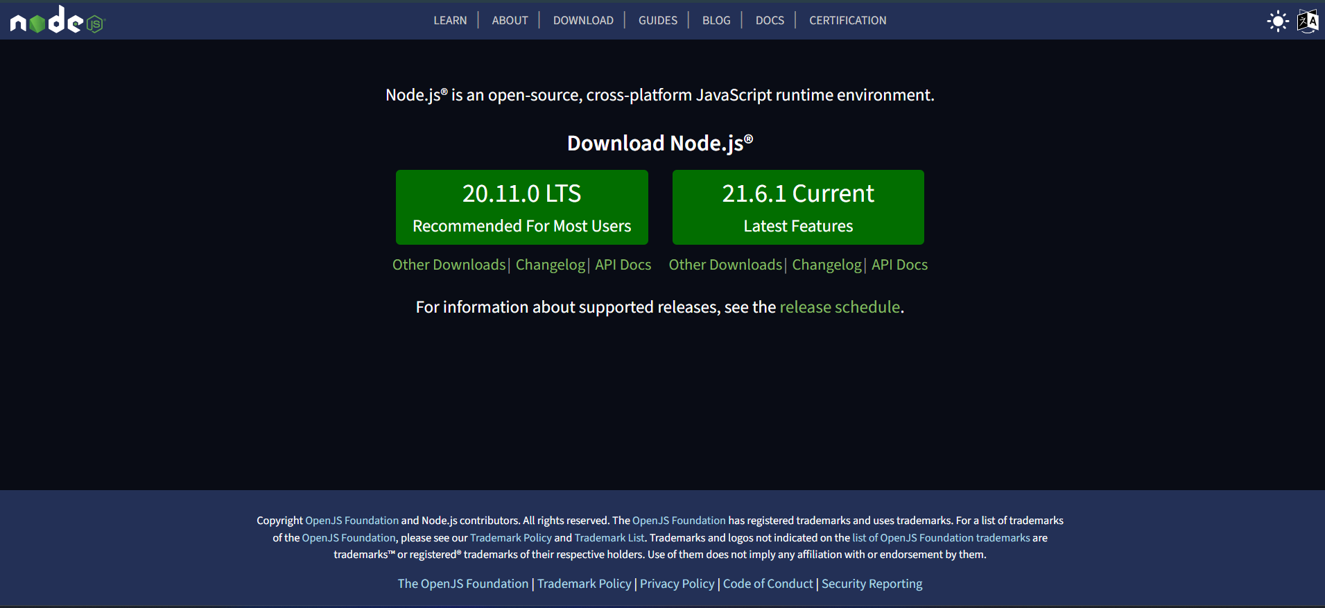

* 1. Download and install Android Studio App. To properly install the software, follow the step-by-step instructions on the website that was provided.
  2. Select Android Virtual Device when choosing the components.

* 1. When installing Android Studio, installation type should be “Standard.”
  2. When choosing a path when installing Android SDK, make sure you it is not connected to OneDrive.

1. Configuration steps: Detail any necessary configuration steps required to set up the framework, such as setting environment variables or configuring project settings.
   1. After setting up the Android Studio, configure ANDROID_HOME environment. Step-by-step process is provided in the website.

Variable should be ANDROID_HOME

Value should be the Sdk path

* 1. Add the platform-tools by editing the environment variable.

Click Edit & add the platform-tools path.

1. Project creation: Outline the steps involved in creating a new project using the framework, including any necessary setup or configuration.
   1. Open command prompt. To avoid unexpected issues, run the following command prompt:



* 1. To create a new application, run the following command prompt:



After the word “init” should be the name of your React Native project. I named it ‘Awesome Project.’ I just followed the instructions via website.

* 1. When a prompt says that you need to install packages, install them by typing ‘y’. After that, wait for it to install all the necessary packages.

1. Running the project: Detail how to run the project in an Android Device Simulator.
   1. Before we can run the project, we should setup a device emulator in the Android Studio. To do this, in your Android Studio app, click on ‘More Actions’ and choose ‘Virtual Device Manager.’ Make sure that you choose a phone device.
   2. To run the project, type ‘npm run start’ (make sure you are in the correct path of your project)

